Name : Mriganka Patra
Emp id: 2415820
Email : mriganka.patra@cognizant.com

Day 10

Assignment 1:

Salesforce – Opportunities, Sales Path and Full Sales Cycle
Objective:
Learn to manage Opportunities, Configure Sales Path, and Demonstrate the Complete Sales Cycle within Salesforce.
Tasks:
- Create a new Opportunity and Walk through the default stages: Prospecting to Closed Won / Lost
- Add products to the Opportunity from a Pricebook:
- Include a least 2 different Products with quantities and discounts
- Customize a Sales Path for Opportunities:
- Define key fields and guidance for each stage.
- Simulate a full Sales Cycle:
- Convert a Lead – Create an Account & Contact – Create an Opportunity – Add Products – Close Opportunity
- Use Activity Timeline to log a call , schedule a task, and send an email from the Opportunity record
Deliverables:
- Screenshots or Configuration of Opportunity stages and Sales Path
- Product details within the Opportunity
- Demonstration of complete sales cycle steps

Task 1:Create a new Opportunity and Walk through the default stages: Prospecting to Closed Won / Lost

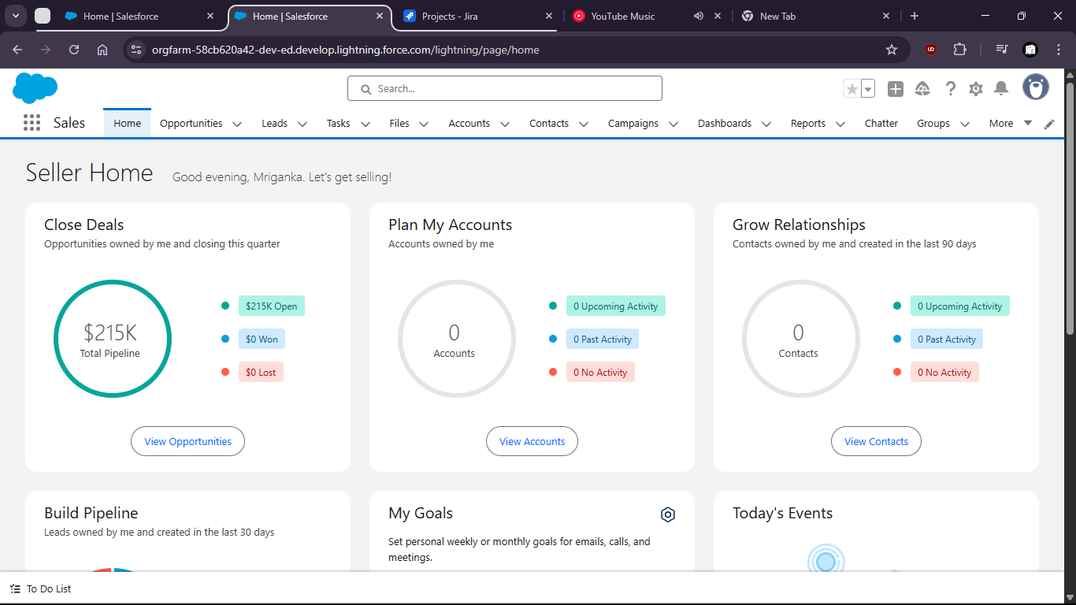

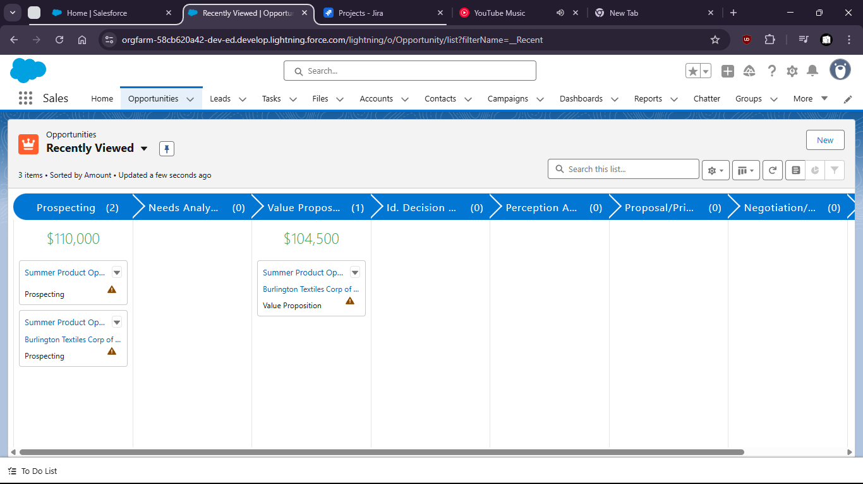

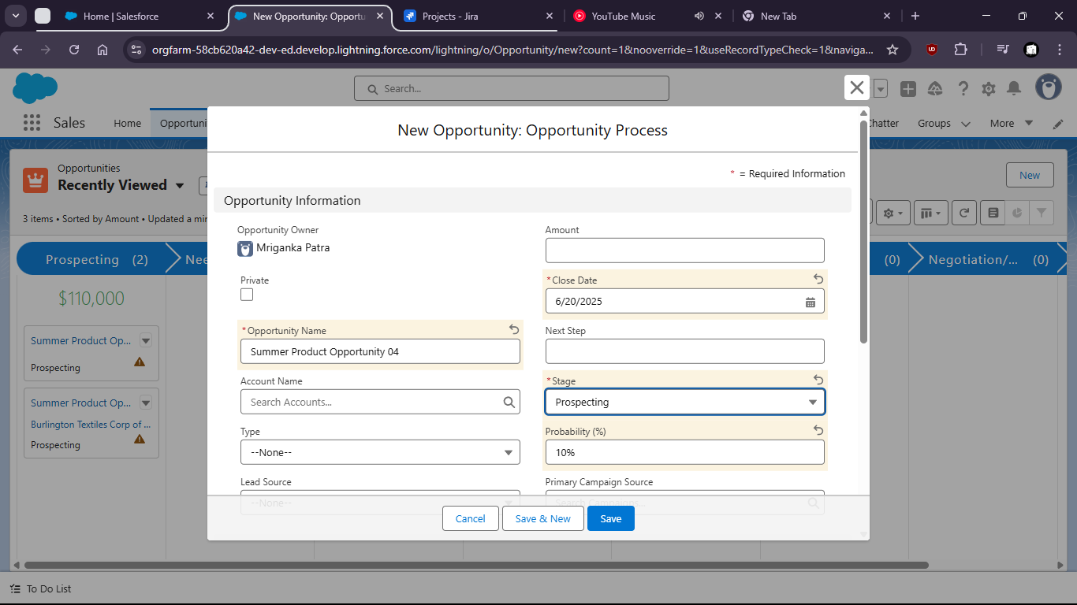

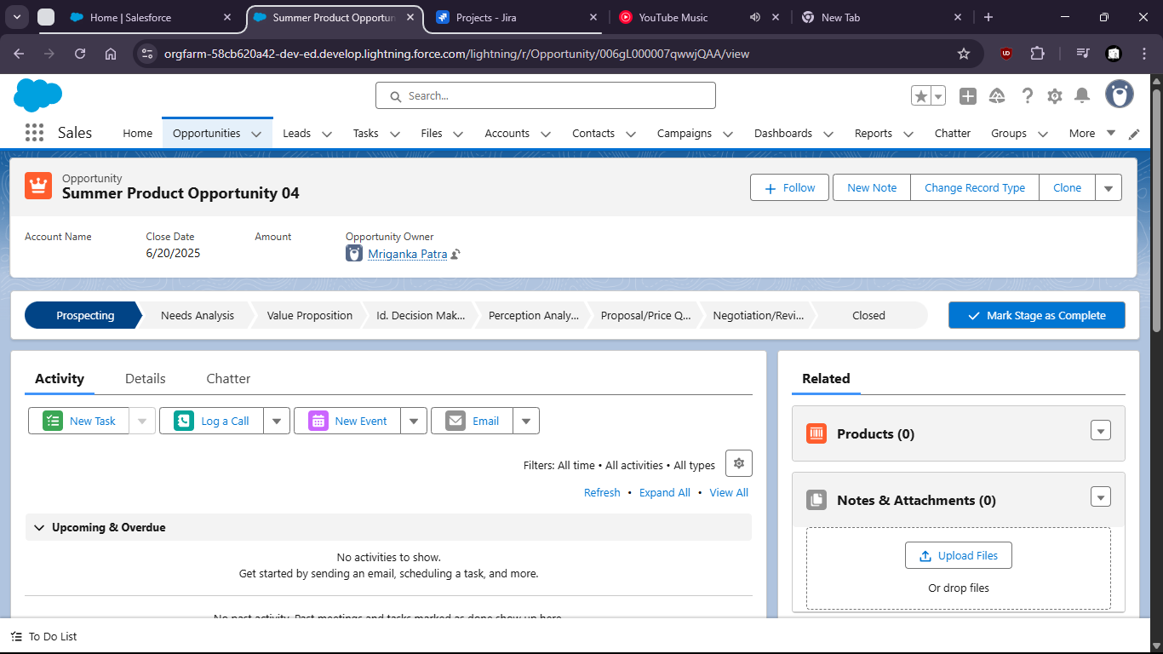

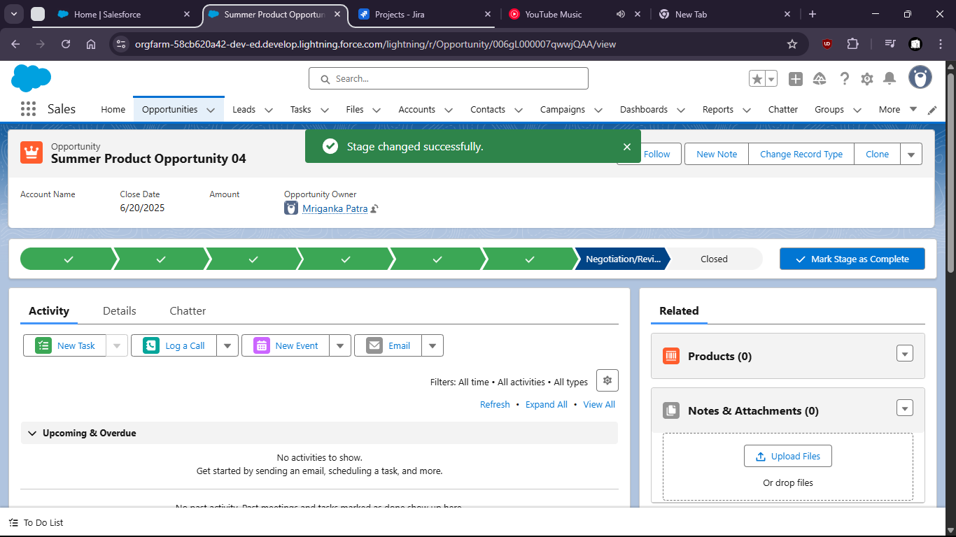

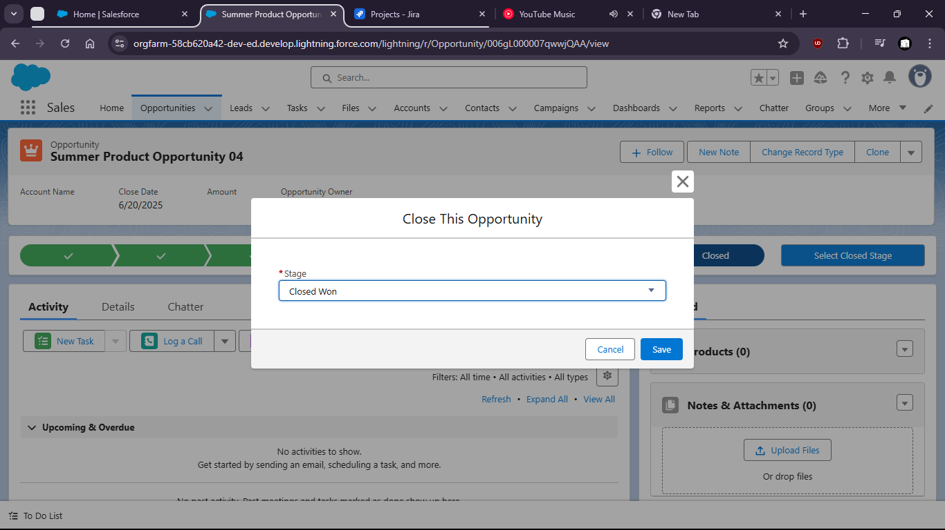

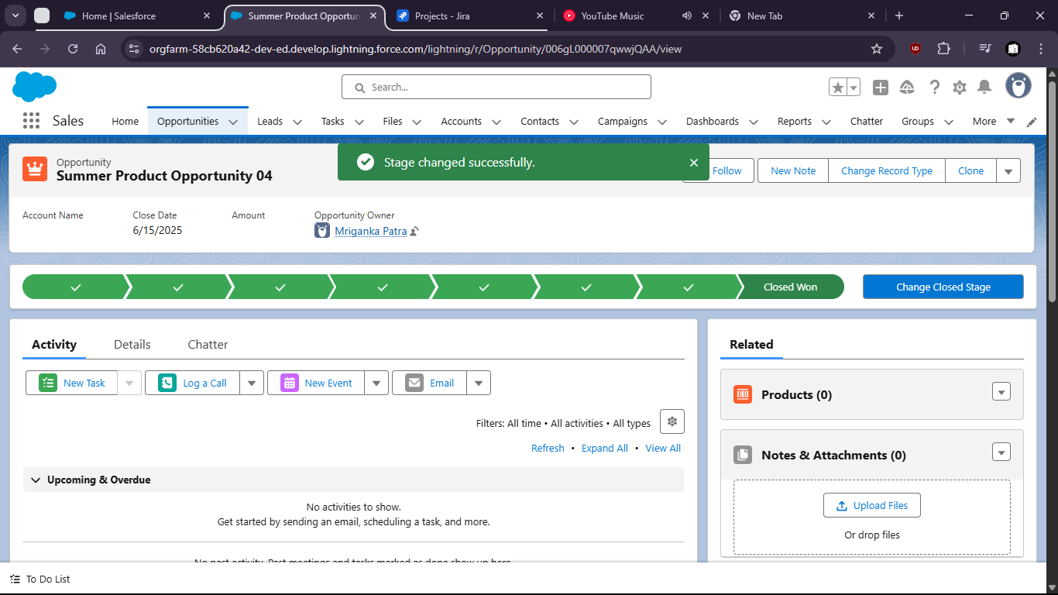

Task 2:Add products to the Opportunity from a Pricebook:
Include a least 2 different Products with quantities and discounts

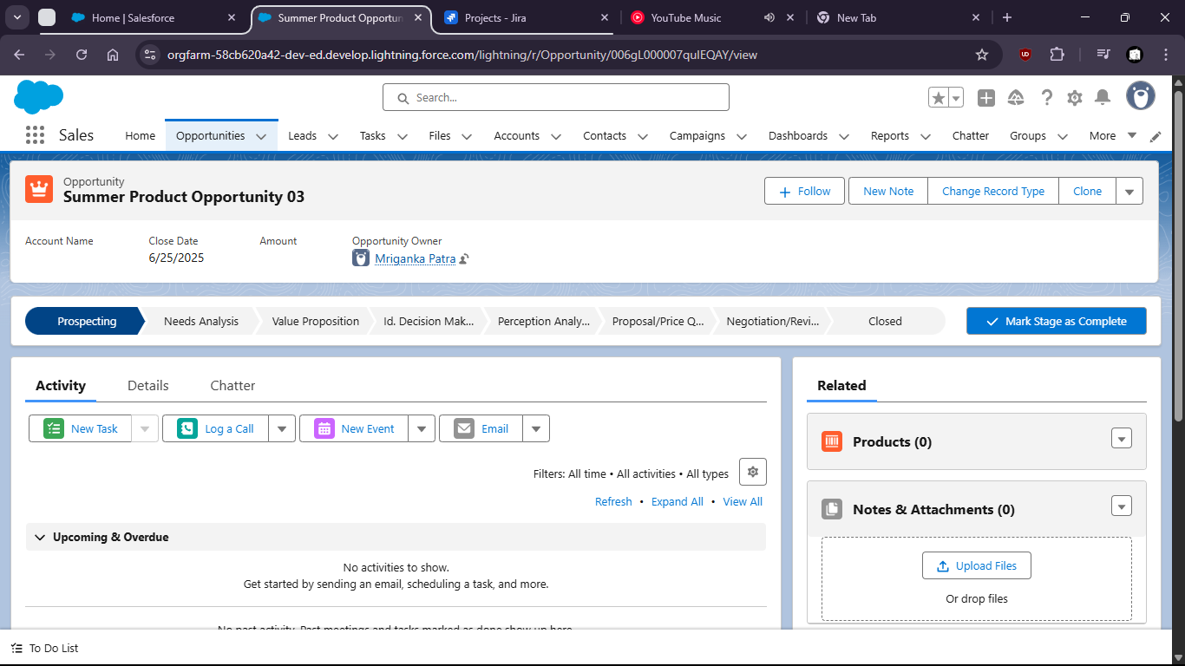

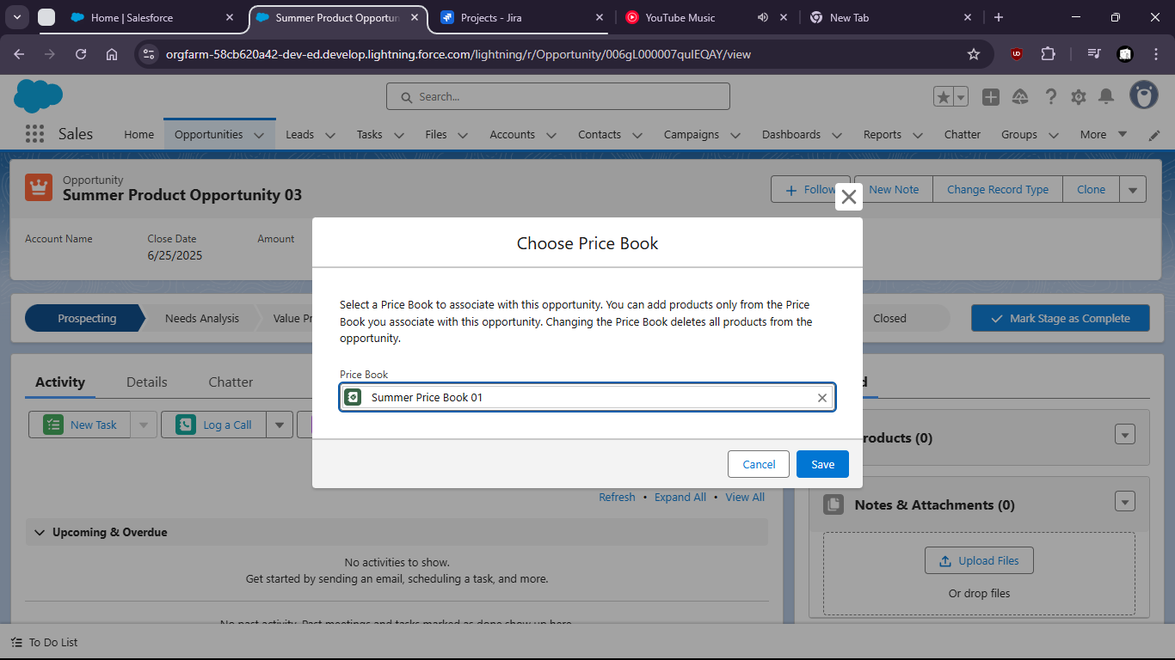

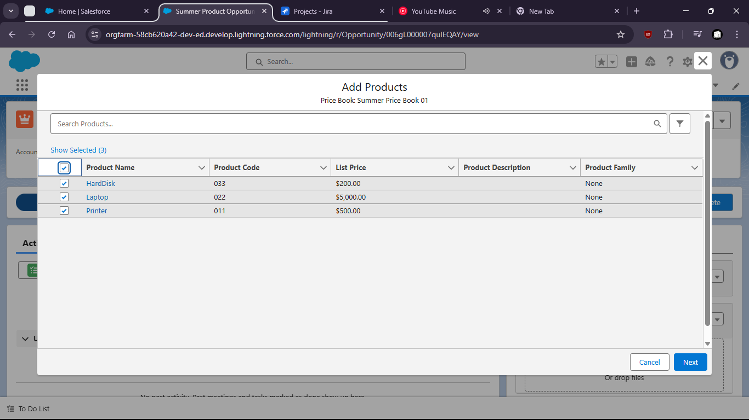

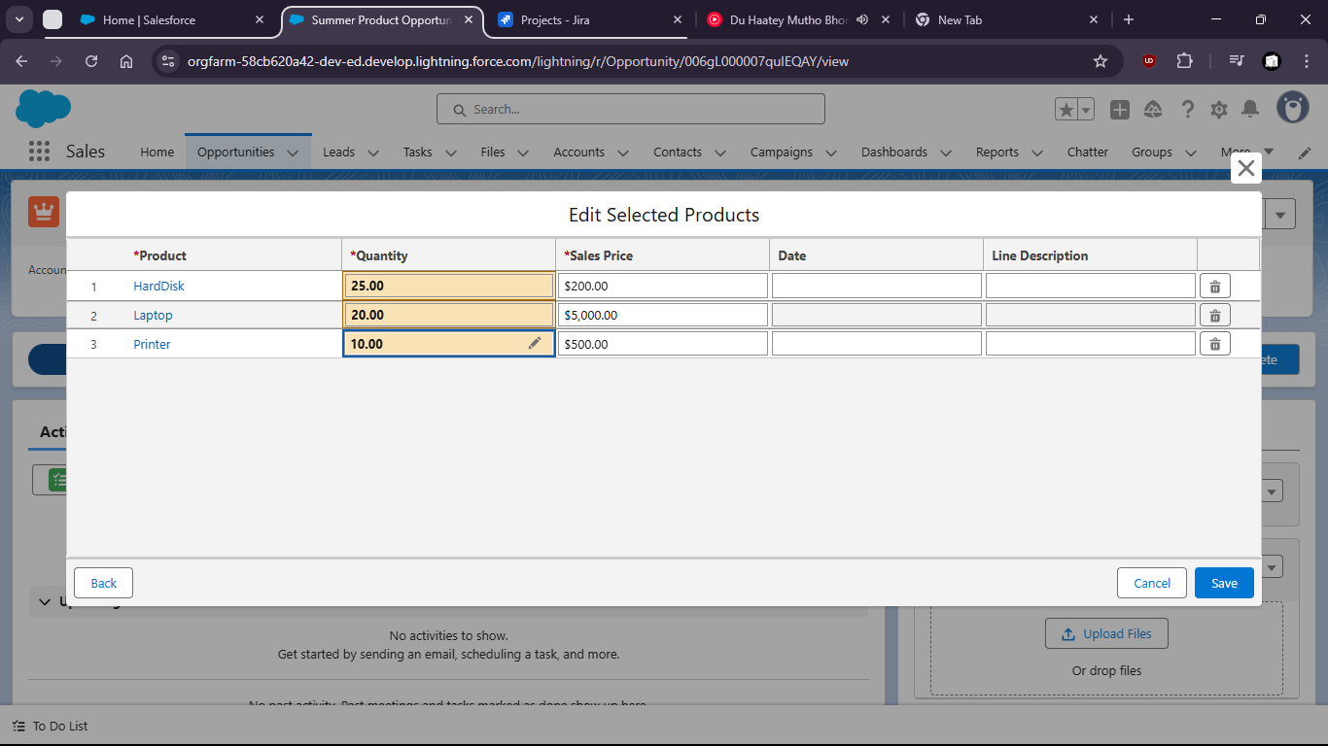

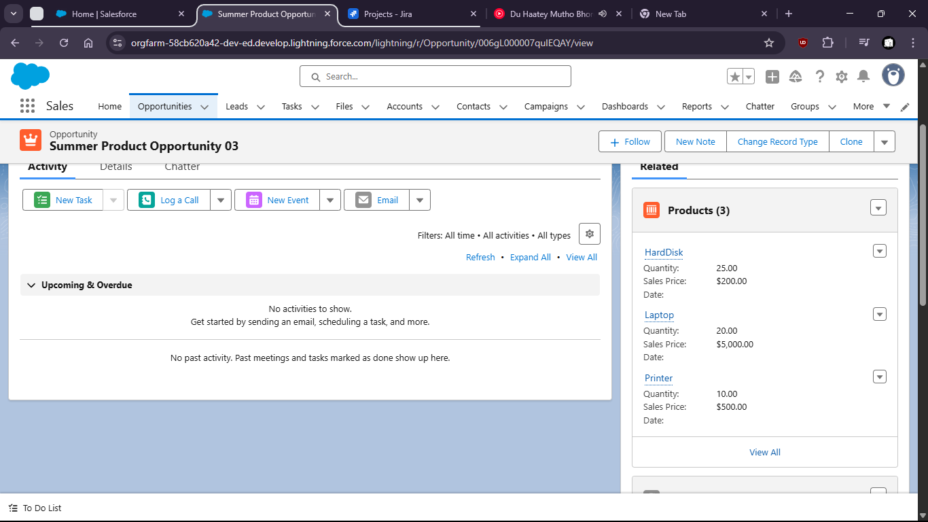

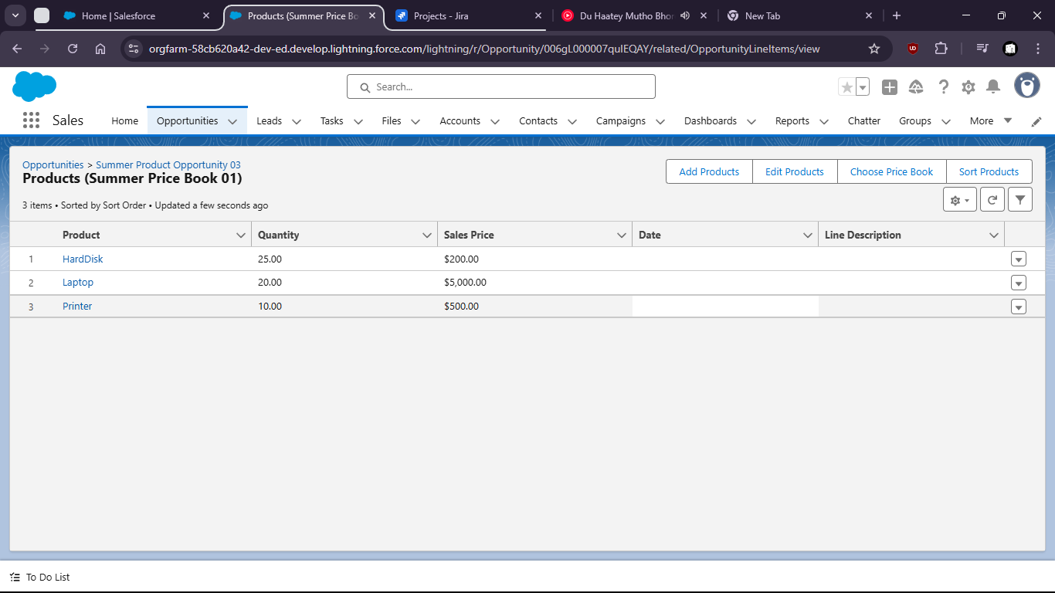

Task 3:Customize a Sales Path for Opportunities:
Define key fields and guidance for each stage.

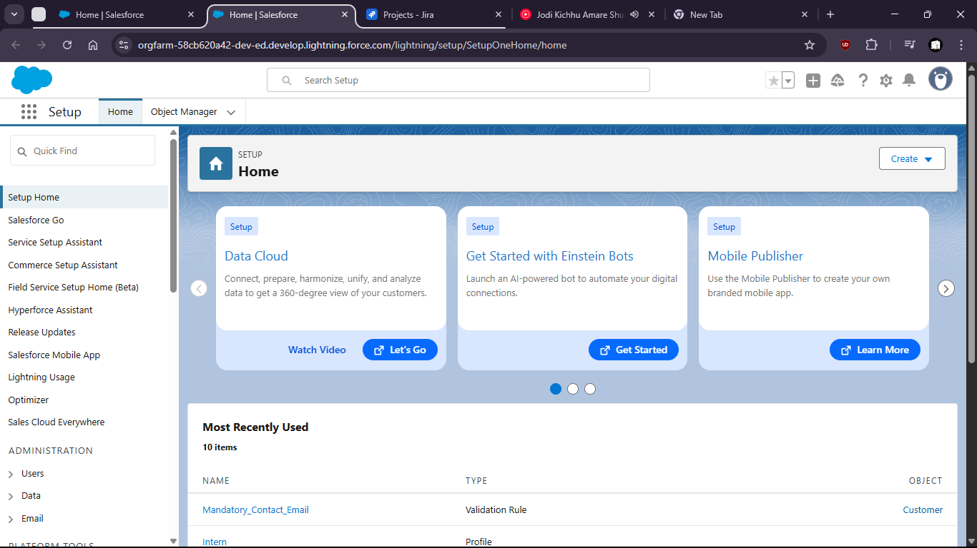

Goto setup > home > path settings.

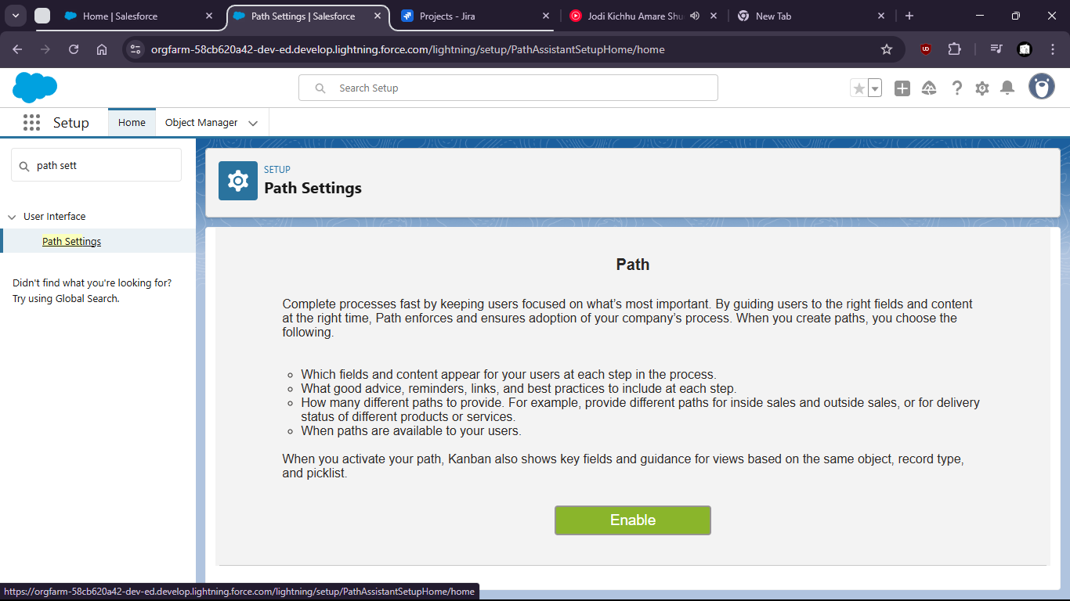

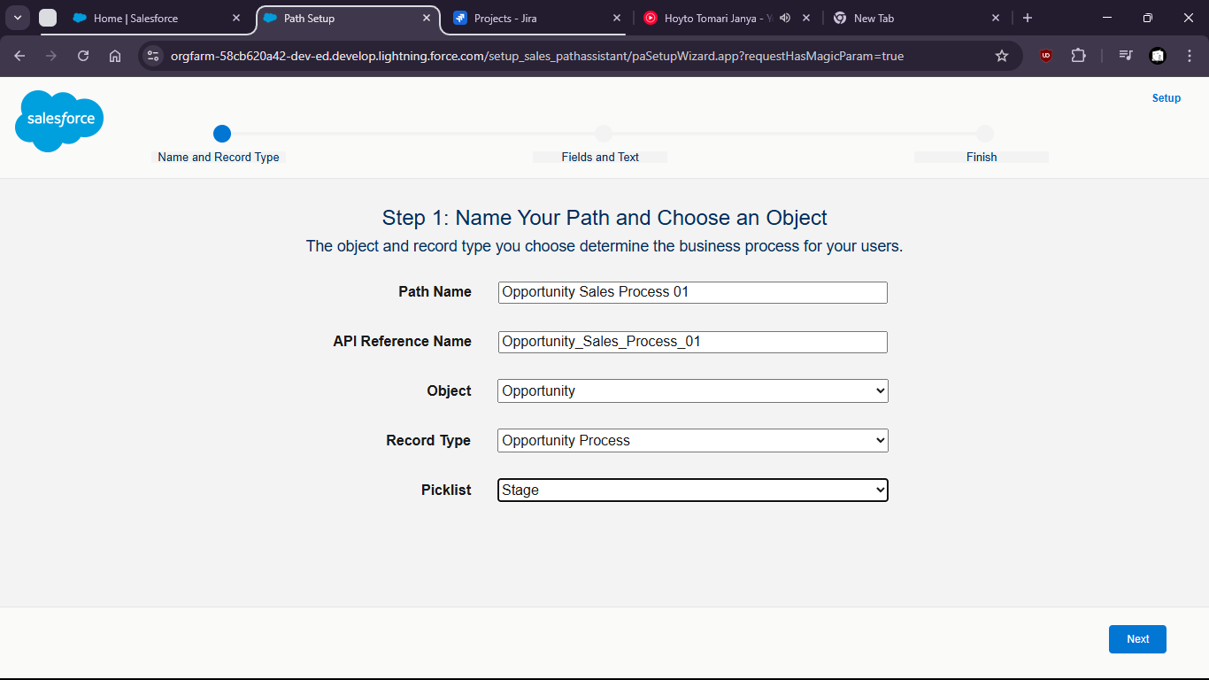

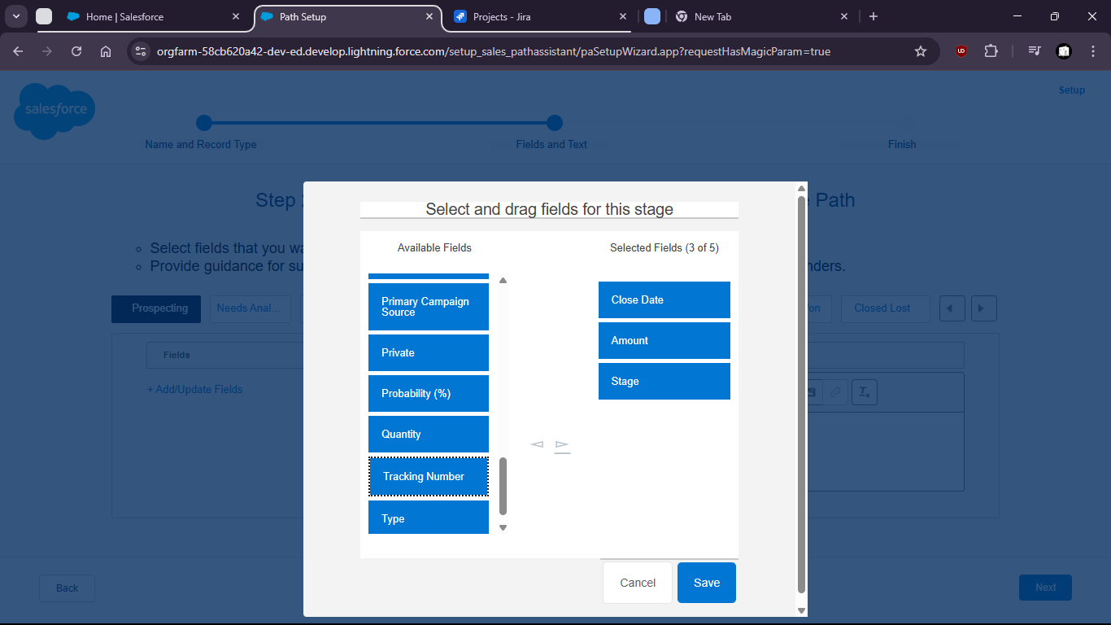

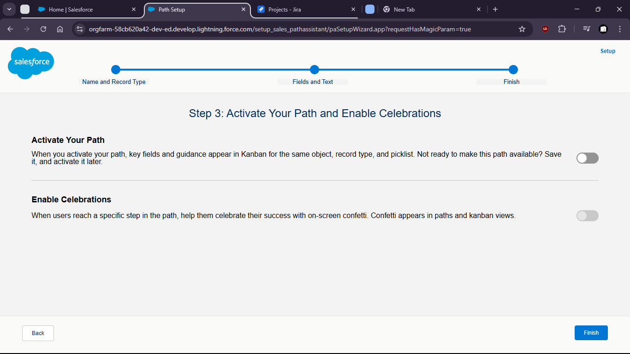

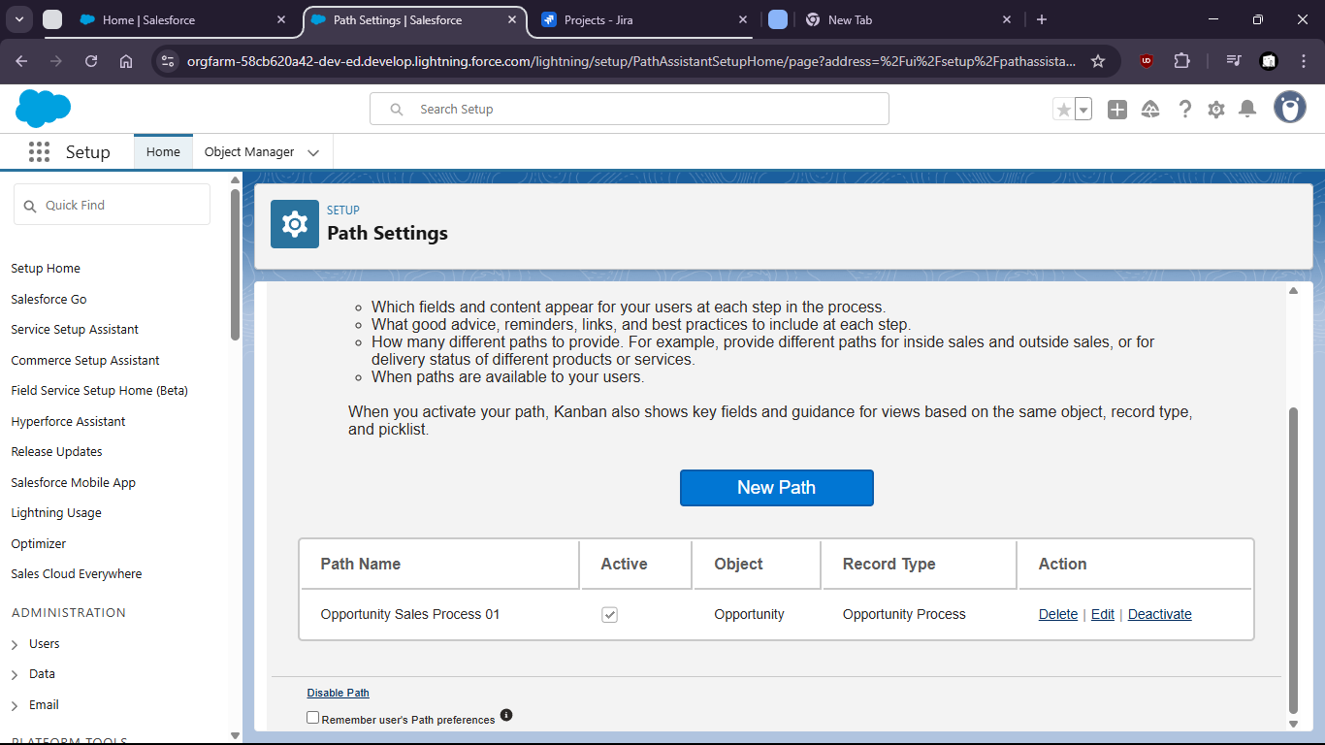

Task 4:Simulate a full Sales Cycle:
Convert a Lead – Create an Account & Contact – Create an Opportunity – Add Products – Close Opportunity

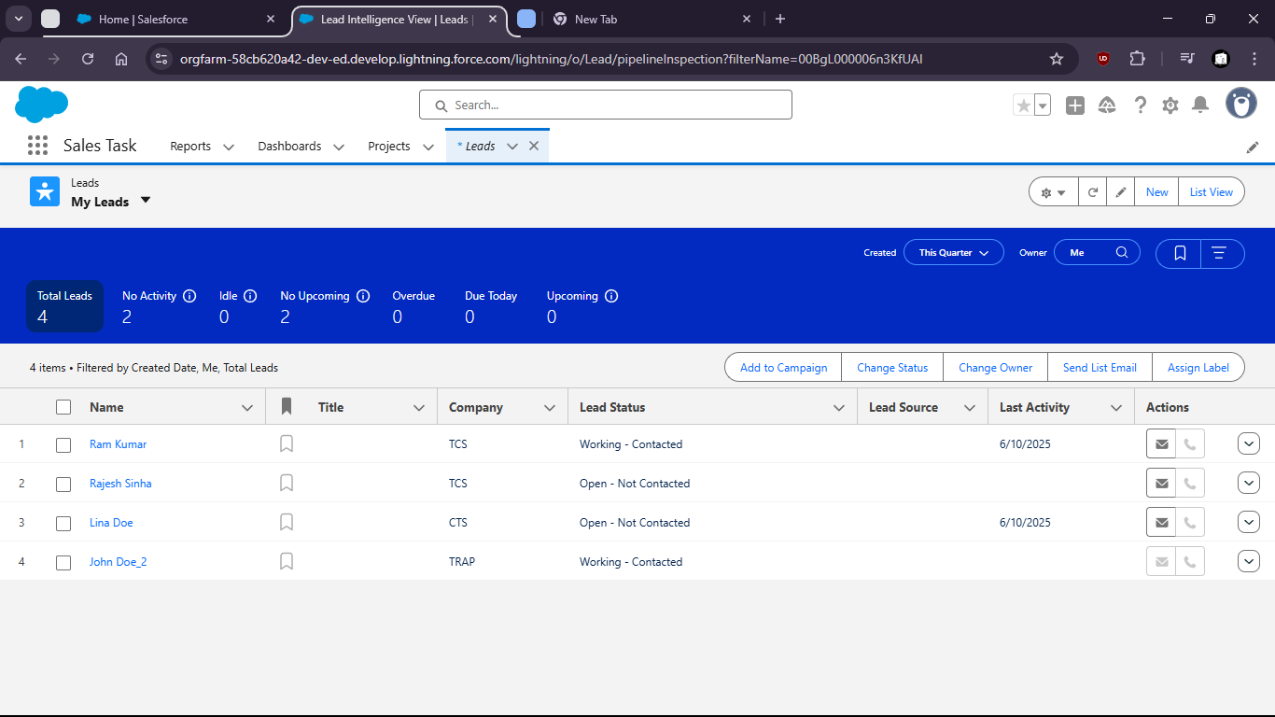

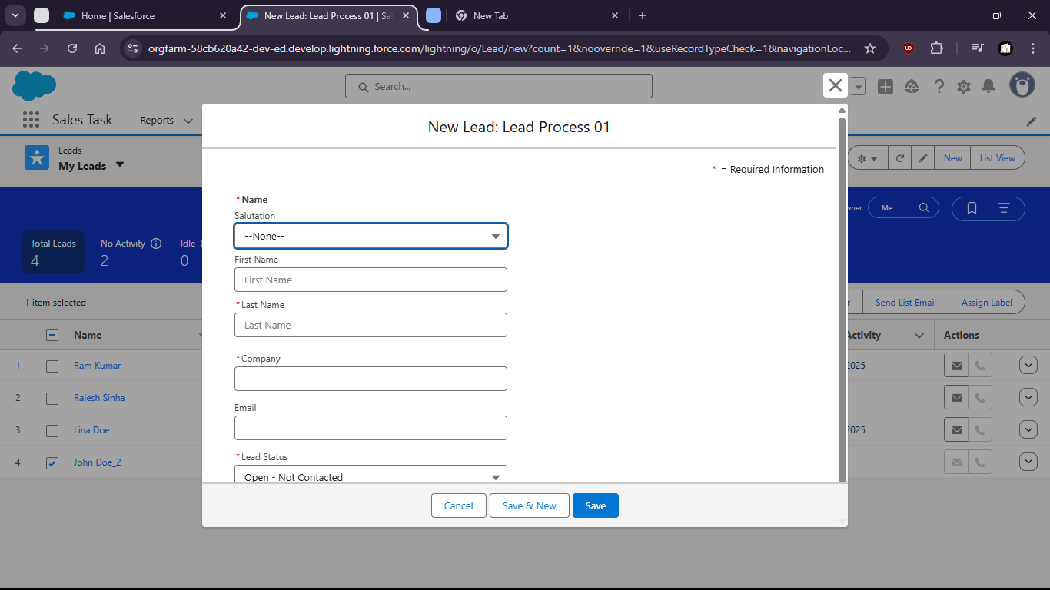

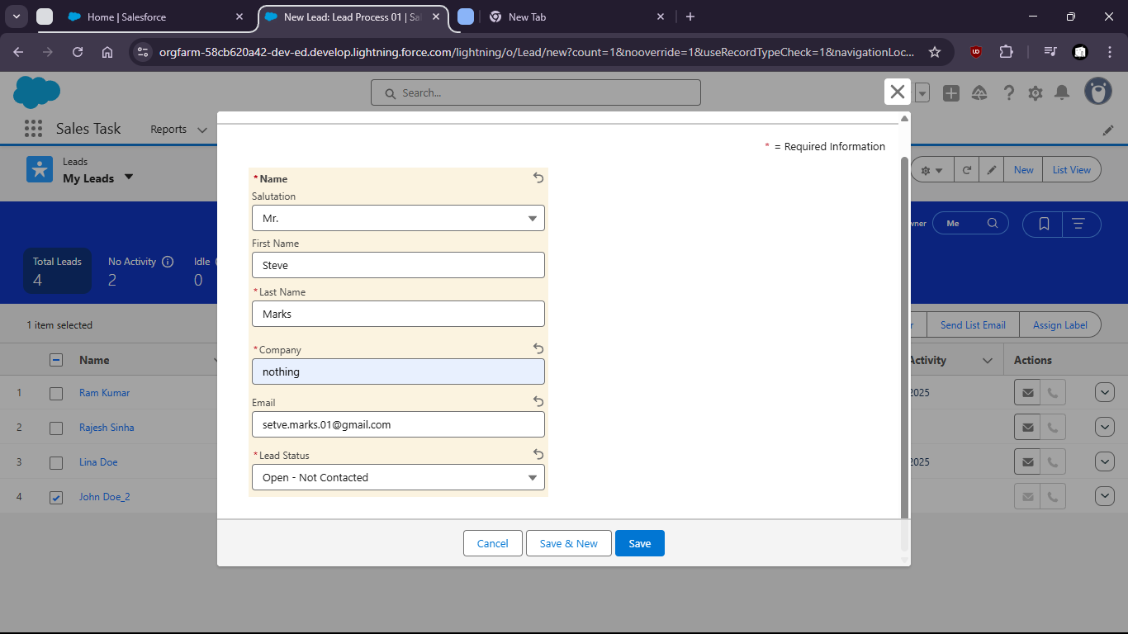

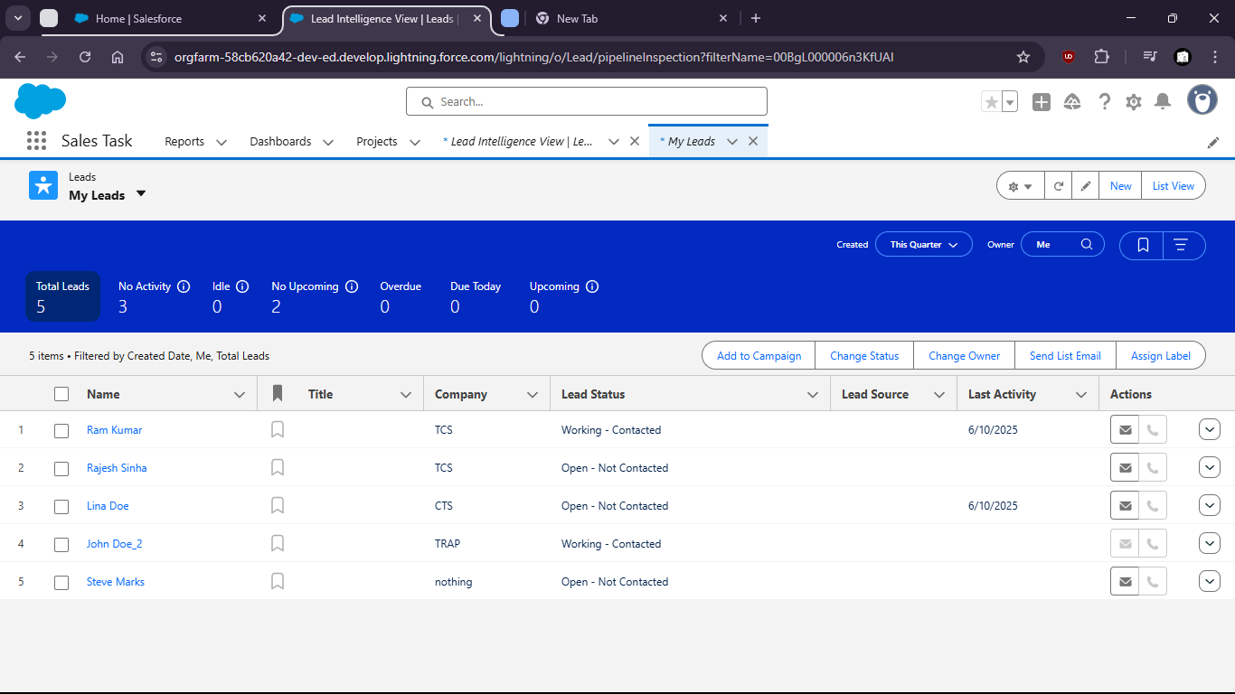

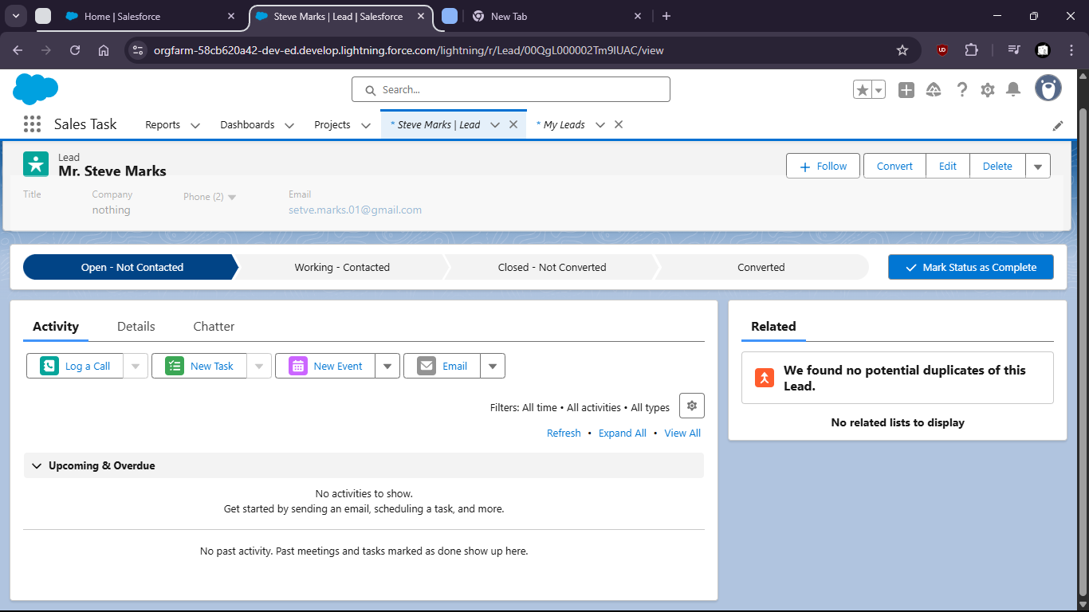

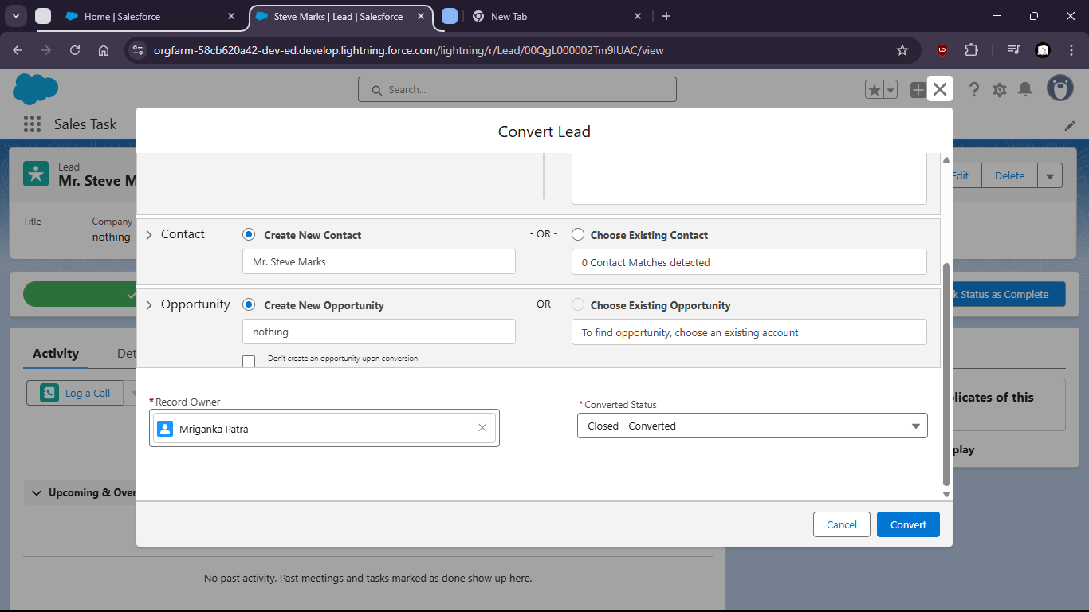

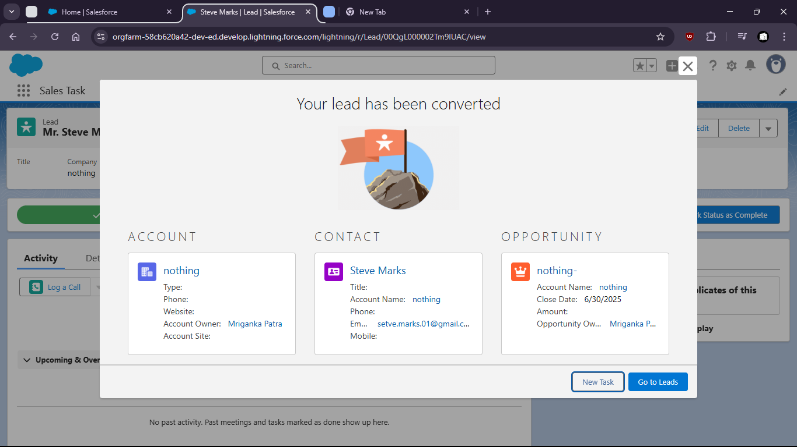

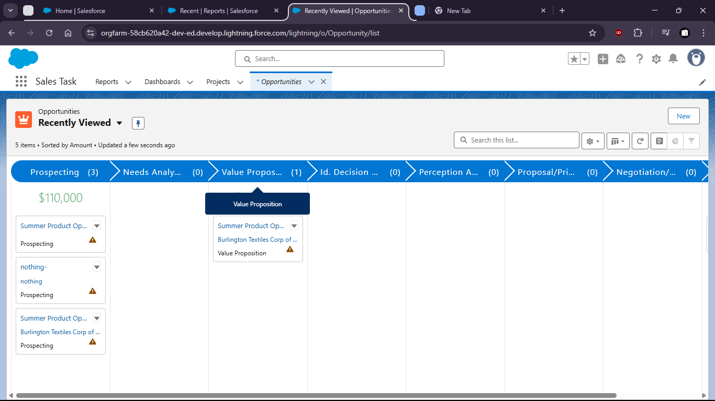

Task 5:Use Activity Timeline to log a call , schedule a task, and send an email from the Opportunity record

